

**SECP1513-TECHNOLOGY AND INFORMATION SYSTEM**

**20242025 – SEMESTER 1**

**GROUP ASSIGNMENT**

**DESIGN THINKING**

**Topic: Generative Artificial Intelligence**

**GROUP A&C**

|  |  |
| --- | --- |
| **NAME** | **MATRIC ID** |
| **Liu Wanpeng** | **A23MJ4016** |
| **Liu Ruoyang** | **A23MJ4022** |
| **Bu Guoshun** | **A23MJ4019** |
| **Zhao Wei** | **A23MJ4018** |

1. **Introduction**

The emergence of Generative Artificial Intelligence (Generative AI) has opened doors for innovative applications in diverse fields, providing new ways to create content, solve problems, and boost productivity. This report applies the design thinking process to explore how Generative AI can address the needs of ordinary users, focusing on collaboration, innovation, and practical implementation.

1. **Empathy**

To understand the potential users of Generative AI, we identified three user personas representing real-world challenges. Below are the personas, their questions, and our responses:

**User Persona 1: University Student**

* **Name:** Yang Jingwen
* **Age:** 20
* **Background:** Undergraduate student majoring in computer science.
* **Technical Proficiency:** Moderate
* **Key Responsibilities:**
  + Balancing coursework, projects, and personal growth
  + Accessing and synthesizing diverse learning resources
  + Preparing reports and assignments efficiently

**Questions and Responses:**

1. **How can Generative AI help students handle large amounts of academic materials?**
   * **Response:** Generative AI can summarize lengthy documents, extract key points, and suggest further reading, making it easier for students to navigate complex subjects.
2. **What tools can AI offer to improve the quality of academic writing?**
   * **Response:** AI-powered writing assistants can refine grammar, ensure clarity, and provide suggestions for improving structure and flow.
3. **How can AI help with time management in academic projects?**
   * **Response:** AI tools can generate personalized study plans and track deadlines, enabling students to prioritize tasks effectively.

**User Persona 2: Small Business Owner**

* **Name:** Wu Yuzi
* **Age:** 30
* **Background:** Owner of a local bakery with a small team.
* **Technical Proficiency:** Low
* **Key Responsibilities:**
  + Managing daily operations
  + Marketing products to attract new customers
  + Enhancing customer engagement

**Questions and Responses:**

1. **How can Generative AI help in creating promotional content?**
   * **Response:** Generative AI can produce attractive social media posts, design digital advertisements, and craft engaging emails tailored to the target audience.
2. **What tools can simplify AI adoption for non-technical users?**
   * **Response:** User-friendly AI platforms with drag-and-drop interfaces and pre-designed templates ensure accessibility for individuals with minimal technical expertise.
3. **How can AI help with customer interaction and retention?**
   * **Response:** AI chatbots can handle common queries, collect feedback, and suggest personalized product recommendations, enhancing customer satisfaction and loyalty.

**User Persona 3: Graphic Designer**

* **Name:** Wang Yaoke
* **Age:** 29
* **Background:** Freelance designer specializing in branding and illustration.
* **Technical Proficiency:** High
* **Key Responsibilities:**
  + Designing creative visuals for clients
  + Managing project timelines and client expectations
  + Keeping up with design trends and tools

**Questions and Responses:**

1. **How can Generative AI improve the creative process in design?**
   * **Response:** Generative AI can create concept art, suggest design variations, and generate mockups, allowing designers to focus on refining ideas.
2. **What tools can ensure that AI outputs align with unique client requirements?**
   * **Response:** Customizable AI systems allow designers to input brand-specific guidelines, ensuring outputs align with the client’s vision.
3. **How can AI enhance efficiency in repetitive design tasks?**
   * **Response:** AI tools can automate resizing, format adjustments, and color matching, saving time for more creative endeavors.
4. **Define**

Following the Empathy phase, we structured our problem identification process based on the following aspects:

1. **Problems Need to Be Addressed**
   * Handling Large Volumes of Information: Students struggle to process academic materials efficiently, while small business owners face challenges in creating engaging promotional content.
   * Time Management: Freelancers often face tight deadlines, requiring solutions that can automate repetitive tasks to save time.
   * Personalization: Marketing campaigns often lack adequate customization, reducing their effectiveness.
2. **Current Progress Toward Solving the Problems**
   * Generative AI tools like summarization engines and automated content creation platforms exist, but many lack usability for non-technical users.
   * Advanced AI models provide creative suggestions, but they are often expensive and inaccessible to smaller organizations or individuals.
3. **Advantages of the Current Solutions**
   * Existing AI systems demonstrate remarkable speed and accuracy in generating content, enabling users to achieve tasks that would otherwise take hours.
   * Some platforms provide customization capabilities that cater to specific industries, such as retail or education.
4. **Potential New Solutions**
   * A learning assistant tailored for students to summarize complex academic material and generate study plans.
   * A marketing assistant designed for small business owners, offering user-friendly interfaces and pre-designed templates for content creation.
   * A creative design companion to aid freelancers in automating repetitive design tasks while generating innovative ideas.

By defining these areas, we ensured a focused and actionable approach to the ideation and prototyping phases of our project.

1. **Lack of Contextual Understanding**
   * AI-generated outputs sometimes miss nuanced or industry-specific details, requiring manual intervention for refinement.
2. **Data Privacy Concerns**
   * Users worry about sensitive data being exposed or mishandled during AI training or processing.
3. **Accessibility for Non-Technical Users**
   * Many AI tools are not user-friendly for individuals without technical expertise, limiting their adoption.
4. **Bias and Ethical Issues**
   * Generative AI may inadvertently produce biased or ethically questionable content, which could damage user trust.
5. **Ideate**

The ideation process for Generative AI was divided into two phases: Brainstorm and Select Ideas.

* 1. **Brainstorm**

We conducted a wide-ranging brainstorming session to generate diverse and creative ideas. The goal was to explore various possibilities related to Generative AI, including problems to address, potential solutions, creative use cases, and hypothetical scenarios. Below is the list of ideas generated during this session:

|  |  |
| --- | --- |
| **Idea** | **Description** |
| Real-Time Academic Assistants | AI that provides real-time answers to questions based on lectures or study materials. |
| Personalized Mental Health Support | AI offering empathetic conversations and coping strategies tailored to individual needs. |
| AI-Powered Content Moderators | Tools for detecting inappropriate, biased, or harmful content online. |
| Sustainability Coaches | AI suggesting eco-friendly practices and resource optimizations for households and businesses. |
| Creative Writing Companions | AI that collaborates with users to craft novels, scripts, or poetry. |
| Dynamic Learning Schedulers | AI generating optimized study or work schedules based on user deadlines and energy levels. |
| Virtual Event Managers | AI handling event logistics, such as scheduling, attendee management, and real-time updates. |
| Customer Sentiment Analyzers | AI analyzing customer feedback to suggest actionable improvements for businesses. |
| Fashion Design Assistants | AI generating clothing designs based on current trends and user preferences. |
| AI-Generated Storyboards | Tools for creating visual outlines of film, animation, or advertising projects. |
| Language Adaptation for Business | AI that translates and adapts content for cultural relevance in international markets. |
| On-Demand Hobby Trainers | AI teaching skills like cooking, painting, or playing musical instruments with tailored lessons. |
| Generative Urban Planners | AI creating smart city layouts with sustainability and efficiency in mind. |
| AI-Driven Prototyping Tools | Tools that generate 3D models or wireframes based on user sketches or inputs. |
| Interactive AI Historians | AI recreating historical events or generating virtual tours of historical landmarks. |

* 1. **Select Ideas**

After generating a broad spectrum of ideas, we critically evaluated each one based on feasibility, relevance, and potential impact. The following ideas were selected for further exploration and analysis:

**Real-Time Academic Assistants**

* + Reason for Selection: Students often struggle to keep up with complex academic materials. This idea addresses a universal challenge by offering real-time support.
  + Potential Impact: Enhances student productivity and improves comprehension, making learning more accessible.

**Virtual Event Managers**

* + Reason for Selection: The growing trend of virtual and hybrid events creates a demand for tools to simplify logistics and attendee engagement.
  + Potential Impact: Saves time for organizers and improves the overall experience for participants.

**Customer Sentiment Analyzers**

* + Reason for Selection: Businesses require actionable insights to improve customer satisfaction. This tool automates feedback analysis for better decision-making.
  + Potential Impact: Enhances customer loyalty and helps businesses adapt quickly to changing needs.

**5. Prototyping**  
We used Figma to manage the User Interface design and create some situations as the storyboard, or to say prototype, of a generative AI. We named it “GeneratElite” which takes “generate” and “elite” as the features. We hope it can be an elite in generative AI field.

**5.1 Sign Up/Sign In Page**

* **Purpose:** This is the entry point for users to access the GeneratElite AI platform. It allows users to create a new account or sign in with existing credentials.
* **Features:**
  + Email-based account creation.
  + Option to continue with Google for seamless sign-in.

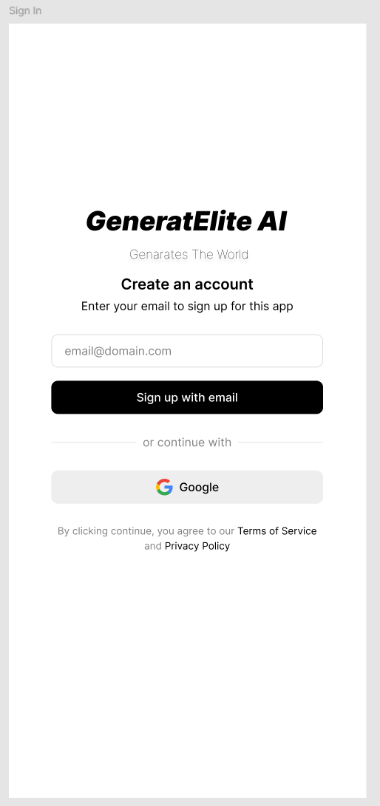

* 1. **Revision List Generation**
* **Purpose:** This page demonstrates GeneratElite AI’s ability to provide tailored study plans based on user input.
* **Scenario:** The user queries for a revision list for a specific subject, such as Technology and Information Systems, and the AI generates a structured list of topics to review.
* 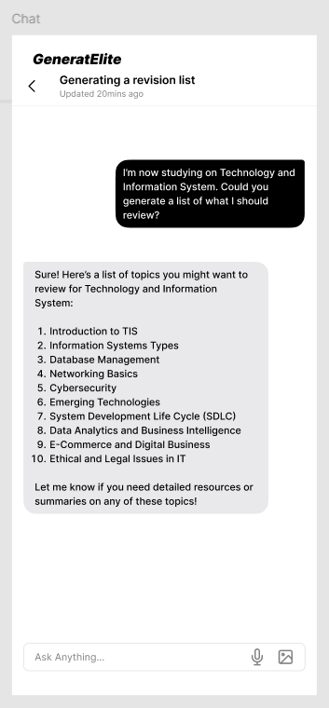**Value:** Helps users save time and focus on relevant content.

**5.3 Image Search for Study Topics**

* **Purpose:** This feature showcases the platform's capability to assist users with visual resources, such as diagrams or infographics.
* **Scenario:** The user requests images related to a topic, e.g., Software Development Life Cycle (SDLC), and the AI retrieves appropriate visuals from the internet.
* 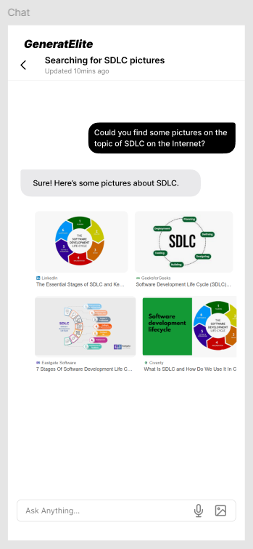**Value:** Enhances learning by providing visual aids to complement textual resources.

**5.4. Translation Assistance**

* **Purpose:** This page highlights the AI's multilingual capabilities, enabling accurate translation and language learning support.
* **Scenario:** The user inputs a Chinese sentence, and the AI provides a precise English translation while offering explanations if needed.
* 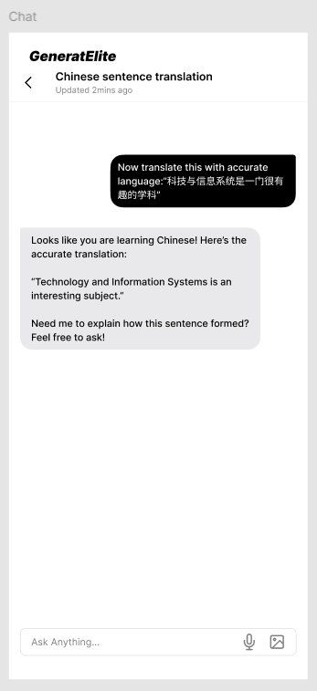**Value:** Supports language learners and professionals needing accurate translations for various contexts.

**6. Test**

The Test phase focuses on validating the functionality and user experience of the **GeneratElite AI** platform. Key areas of testing include:

**a. User Interface (UI) and User Experience (UX)**

**Objective:** Ensure the platform is intuitive and easy to use.

**Tests:**

* + Check if users can easily navigate the Sign Up/Sign In process.
  + Verify the responsiveness and clarity of the design on different devices.

**b. Accuracy of AI Responses**

**Objective:** Validate that the AI provides useful and accurate outputs.

**Tests:**

* + Test the relevance of the Revision List Generation feature with various subjects.
  + Evaluate the accuracy of translations in the Translation Assistance page.

**c. System Performance**

**Objective:** Ensure the platform runs efficiently.

**Tests:**

* + Measure the response time for queries.
  + Conduct basic stress tests to check stability with multiple users.

**d. Feature-Specific Functionality**

**Objective:** Confirm that each feature operates as expected.

**Tests:**

* + Test the accuracy of image searches for educational topics.
  + Verify the consistency of outputs across repeated queries.

It has been confirmed that these tests were conducted without any issues.

**7. Reflections (Individual)**

**Liu Ruoyang**

1. **Goal/Dream:** My goal is to enhance my skills in applying AI technologies to solve real-world problems effectively.
2. **Impact of Design Thinking:** This process has helped me understand the importance of user needs in developing practical AI solutions.
3. **Action/Improvement Plan:** I plan to learn more about AI ethics and user experience design to create better systems in the future.

**Liu Wanpeng**

1. **Goal/Dream:** I aspire to work in innovative AI projects that can make daily tasks easier for everyone.
2. **Impact of Design Thinking:** It showed me how collaboration and brainstorming can bring out creative ideas.
3. **Action/Improvement Plan:** I will focus on improving my teamwork and problem-solving skills by joining more projects like this.

**Zhao Wei**

1. **Goal/Dream:** My dream is to specialize in AI-powered educational tools that benefit students worldwide.
2. **Impact of Design Thinking:** This approach taught me how to integrate user feedback into technical designs effectively.
3. **Action/Improvement Plan:** I will continue to explore different AI tools and study user interaction patterns to improve educational systems.

**Bu Guoshun**

1. **Goal/Dream:** I aim to create AI systems that simplify complex workflows for small businesses.
2. **Impact of Design Thinking:** It made me realize the value of iterative testing and user feedback in system development.
3. **Action/Improvement Plan:** I will enhance my testing methodologies and understanding of user behavior to design better tools.

**Task for Each Member**

|  |  |
| --- | --- |
| **Team Member** | **Task Description** |
| Liu Ruoyang | Conducted user research and created user personas |
| Liu Wanpeng | Organized brainstorming sessions and refined ideas |
| Zhao Wei | Developed prototype designs and assisted in testing |
| Bu Guoshun | Conducted online research and synthesized content into original ideas |